HOTEL HOSPITALITY ANALYSIS

**AtliQ Grands** owns multiple five-star hotels across India. They have been in the hospitality industry for the past 20 years. Due to strategic moves from other competitors and ineffective decision-making in management, AtliQ Grands are losing its market share and revenue in the luxury/business hotels category. As a strategic move, the managing director of AtliQ Grands wanted to incorporate “Business and Data Intelligence” to regain their market share and revenue. However, they do not have an in-house data analytics team to provide them with these insights.  
  
Their revenue management team had decided to hire a 3rd party service provider to provide them with insights from their historical data.

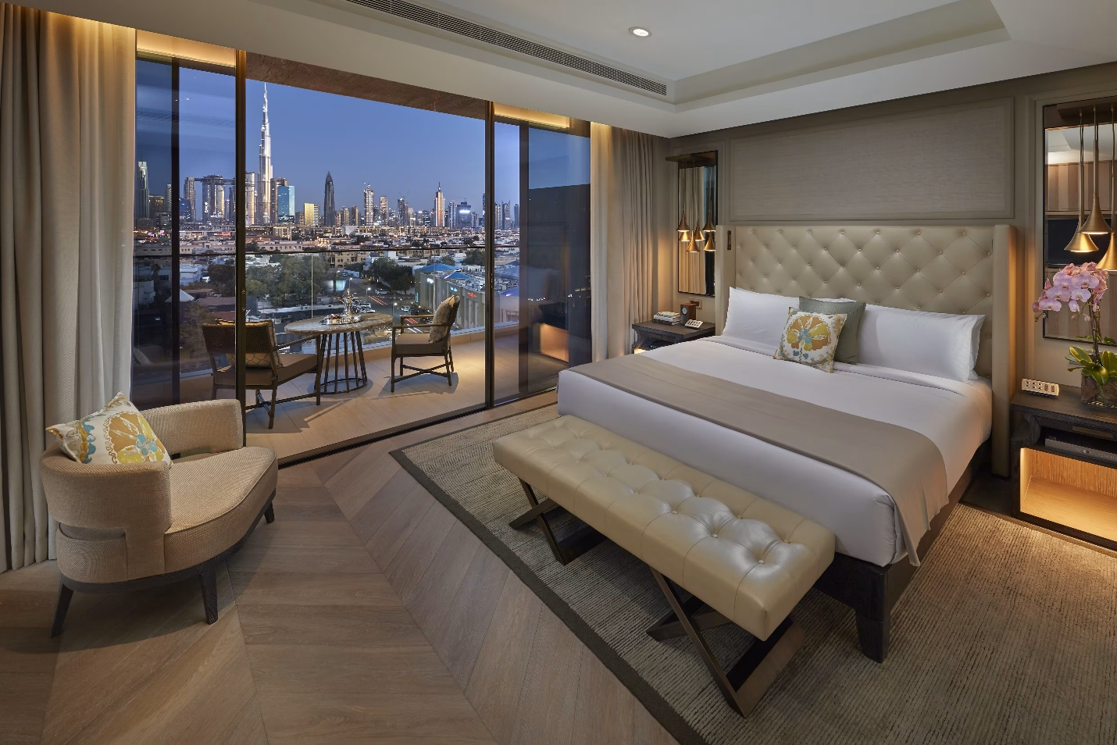

# 🏨 Project Goal: Hotel Performance Dashboard

Atliq Grands owns multiple five-star hotels across India. They have been in the hospitality industry for the past 20 years. Due to strategic moves from other competitors and ineffective decision-making in management, Atliq Grands are losing its market share and revenue in the luxury/business hotels category

# 🎯 Objectives:

1. **Revenue Analysis:**
   * Track total revenue and revenue trends over time.
   * Compare revenue across different hotel properties and platforms.
2. **Guest Analysis:**
   * Understand guest booking behavior and demographics.
   * Analyze average guests per booking and seasonal guest trends.
3. **Room Analysis:**
   * Monitor occupancy % and room utilization.
   * Identify high-performing and low-performing room categories.
4. **Booking Status Analysis:**
   * Track booking trends (confirmed, cancelled, no-show).
   * Calculate cancellation % and understand reasons for booking drop-offs.

## DATA OVERVIEW

### Atliq Hotels Dataset

The dataset used for this project is derived from **Atliq Hotels (5-star hotel chain)** and contains key information related to bookings, guests, rooms, and hotel properties. It has been **cleaned and transformed using Power Query** before building the Power BI dashboard.

1. dim_date

2. dim_hotels

3. dim_rooms

4. fact_aggregated_bookings

5. fact_bookings

Column Description for dim_date:

1. date: This column represents the dates present in May, June and July.

2. mmm yy: This column represents the date in the format of mmm yy (monthname year).

3. week no: This column represents the unique week number for that particular date.

4. day_type: This column represents whether the given day is Weekend or Weekeday.

Column Description for dim_hotels:

1. property_id: This column represents the Unique ID for each of the hotels.

2. property_name: This column represents the name of each hotel.

3. category: This column determines which class[Luxury, Business] a particular hotel/property belongs to.

4. city: This column represents where the particular hotel/property resides in.

Column Description for dim_rooms:

1. room_id: This column represents the type of room[RT1, RT2, RT3, RT4] in a hotel.

2. room_class: This column represents to which class[Standard, Elite, Premium, Presidential] particular room type belongs.

Column Description for fact_aggregated_bookings:

1. property_id: This column represents the Unique ID for each of the hotels.

2. check_in_date: This column represents all the check_in_dates of the customers.

3. room_category: This column represents the type of room[RT1, RT2, RT3, RT4] in a hotel.

4. successful_bookings: This column represents all the successful room bookings that happen for a particular room type in that hotel on that particular date.

5. capacity: This column represents the maximum count of rooms available for a particular room type in that hotel on that particular date.

Column Description for fact_bookings:

1. booking_id: This column represents the Unique Booking ID for each customer when they booked their rooms.

2. property_id: This column represents the Unique ID for each of the hotels

3. booking_date: This column represents the date on which the customer booked their rooms.

4. check_in_date: This column represents the date on which the customer check-in(entered) at the hotel.

5. check_out_date: This column represents the date on which the customer check-out(left) of the hotel.

6. no_guests: This column represents the number of guests who stayed in a particular room in that hotel.

7. room_category: This column represents the type of room[RT1, RT2, RT3, RT4] in a hotel.

8. booking_platform: This column represents in which way the customer booked his room.

9. ratings_given: This column represents the ratings given by the customer for hotel services.

10. booking_status: This column represents whether the customer cancelled his booking[Cancelled], successfully stayed in the hotel[Checked Out] or booked his room but not stayed in the hotel[No show].

11. revenue_generated: This column represents the amount of money generated by the hotel from a particular customer.

12. revenue_realized: This column represents the final amount of money that goes to the hotel based on booking status. If the booking status is cancelled, then 40% of the revenue generated is deducted and the remaining is refunded to the customer. If the booking status is Checked Out/No show, then full revenue generated will goes to hotels.

# DATA CLEANING

Data Cleaning Steps

Before building the dashboard, I cleaned the raw data using Power Query in Power BI. Here's what I did:

• Removed extra columns that weren’t useful for analysis.

• Fixed missing values

• Corrected date formats so I could filter by month and year properly.

• Renamed columns for better readability

## DATA MODEL OVERVIEW

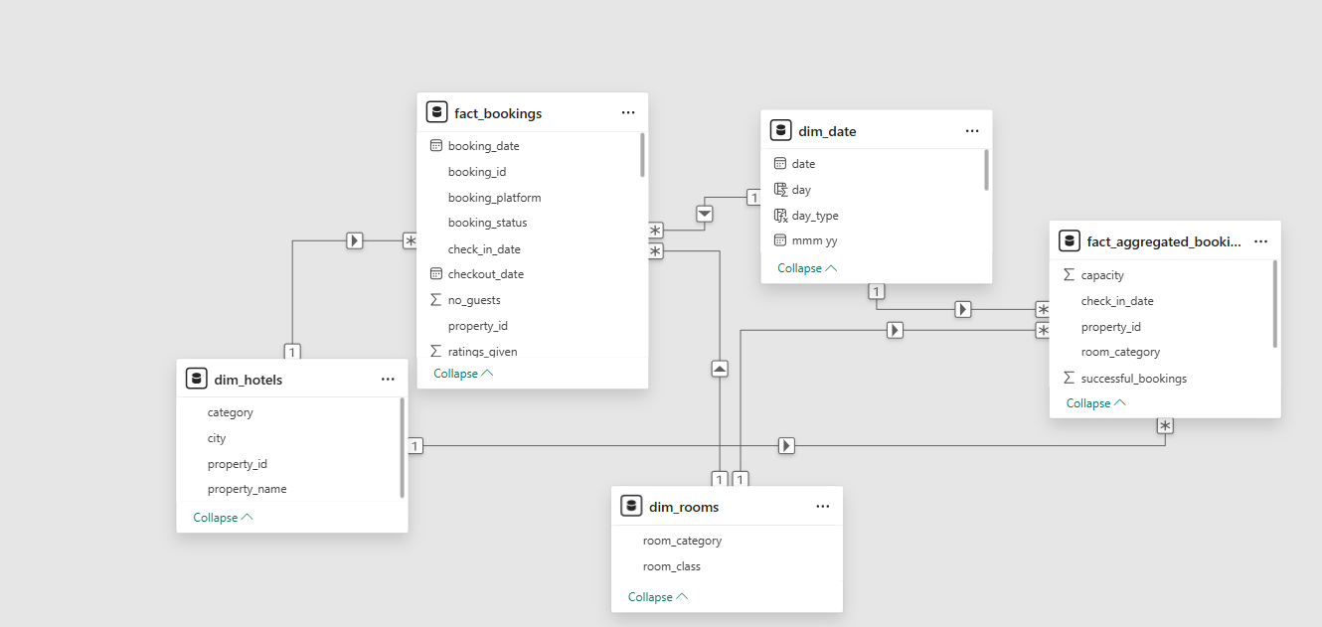

Fact Table

* **multiple fact tables**:
  + fact_bookings (booking-level data)
  + fact_aggregated_bookings (aggregated room capacity data)
* These fact tables **share common dimension tables**:
  + Both use dim_date (for date analysis)
  + Both use dim_hotels (hotel attributes)
* **dim_rooms** is specific to fact_aggregated_bookings, and other dimensions are shared, which is the hallmark of a Galaxy Schema.

USE OF DAX IN THE DASHBOARD

* Occupancy % = DIVIDE([Total Successful Bookings],[Total Capacity],0) * 100
* Average Rating = AVERAGE(fact_bookings[ratings_given])
* Average Rating LM = CALCULATE([Average Rating],DATEADD(dim_date[date],-1,MONTH))
* Cancellation % = DIVIDE([Total cancelled bookings],[Total Bookings])
* Cancellation % LM = CALCULATE([Cancellation %],DATEADD(dim_date[date],-1,MONTH))
* LDC ₹ = [Revenue Genrated ₹]-[Revenue ₹]
* Occupancy % = DIVIDE([Total Successful Bookings], [Total Capacity], 0) * 100
* Occupancy % LY = CALCULATE([Occupancy %],DATEADD(dim_date[date],-1,MONTH
* Realisation % = 1- ([Cancellation %]+[No Show rate %])
* Revenue ₹ = SUM(fact_bookings[revenue_realized])
* Revenue Diff ₹ = [Revenue ₹]-[Revenue LM]
* Revenue Genrated ₹ = SUM(fact_bookings[revenue_generated])
* Revenue LM =

CALCULATE(

    [Revenue ₹],

    PREVIOUSMONTH(dim_date[date])

)

* Revenue on Weekdays ₹ = CALCULATE([Revenue ₹],dim_date[day_type]="Weekday")
* Total Bookings = COUNT(fact_bookings[booking_id])
* Total cancelled bookings = CALCULATE([Total Bookings],fact_bookings[booking_status]="Cancelled")
* Total Capacity = SUM(fact_aggregated_bookings[capacity])

SUMMARY OF EACH VIEW

View 1 :

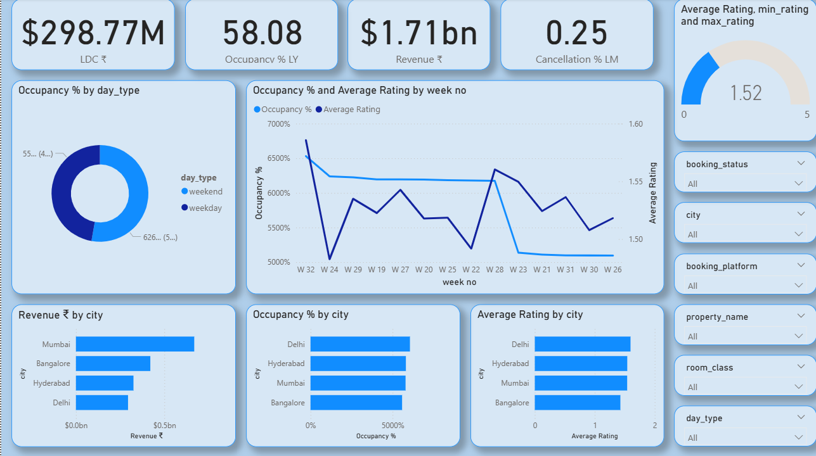

Insights:

* Revenue is strong, led by Mumbai.  
  Delhi leads in occupancy % and guest ratings.
* Average rating is low (1.52/5), which may affect long-term loyalty.
* Occupancy % is higher on weekdays than weekends, suggesting business travel dominance.
* Cancellation % is low, which is positive for revenue stability.

VIEW 2 :

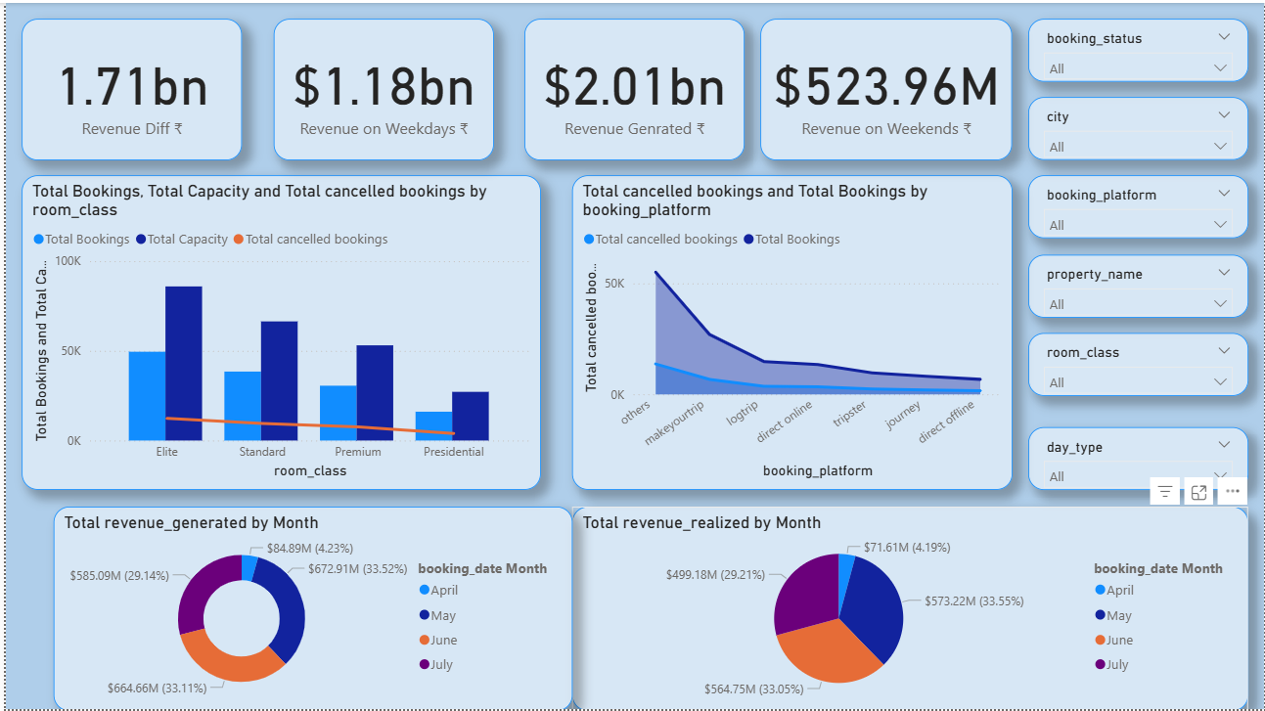

Insights:

*Weekdays dominate revenue generation

* Elite room class drives most bookings but faces higher cancellations.  
* May is the peak month for both revenue generated and realized.

* High cancellations from platforms like "Others" and "Makeyourtrip" need attention.
* July’s revenue is low, possibly due to seasonality